***DJ Pyoneer Neterlan***

*“Notes producer”*

By

Tony (YIT19488399)

Supervisor: Dr Li; Second marker: Dr Clarke

Submitted to

**The University of Roehampton**

**London, England, UK**

In partial fulfilment of the requirements

for the degree of

**BACHELOR OF SCIENCE IN COMPUTER SCIENCE with HONOUR**

**(UCAS Code:** G400**)**



Abstract

Abstract narrative

**Declaration**

I hereby certify that this report constitutes my own work, that where the language of others is used, quotation marks so indicate, and that appropriate credit is given where I have used the language, ideas, expressions, or writings of others.

I declare that this report describes the original work that has not been previously presented for the award of any other degree of any other institution.



**Date:** Friday, 24 March 2023

**Tony**

Acknowledgements

Sincere thanks to my main supervisor, Dr Li who support me every week all the academic year. Very helpful the meetings and discussions. Helping to reference, advising about GitHub, and most importantly giddying and supervising the flow of the project.

Dr Gu from AI and ML was very supportive at the beginning, with recommendations and ideas.

Dr Charles Clarke who assisted and guided me in class, and elaborated questions about my project to me find the best answers. Music theory was necessary to read to understand better the project.

I would also like to extend my thanks for this project be possible because Mr. Valerio Velardo published it online in different channels as his own website, his YouTube channel, and his GitHub repository. Bigger projects as Magenta from Google for example was not useful at all.

Finally, Mr. Ahmad, Mss Aksid and again Dr Gu give me the knowledge on his/her modules that I applied. Ethics, mathematics, and data knowledge is observable in the project.

Table of Contents

**1.** **Introduction** 7

Research Question or Problem that will be Addressed 7

Aims 7

Objectives 7

Legal, Social, Ethical and Professional Considerations 7

Background 7

Report overview 7

**2.** **Literature or Technology Review** 8

**3.** **Design or Methodology** 9

**4.** **Implementation or Results** 10

Evaluation 10

Related Work 10

**5.** **Conclusion** 11

Reflection 11

Future Work 11

**6.** **References** 12

**7.** **Appendices** 13

# **Introduction**

Music generation with few past musical notes using machine learning architecture and techniques in a computer system. The output product is musical notes production that are interpreted as sound by human system. And the idea is that the human ear like the music, use this computer production to inspire human production and much more. Because this project begins with modules like machine learning, the project applies those learnings at the beginning. In the second semester of BSc computer science, modules cyber security updated the route of this final year project. The project is in constant evolution and construction! This report begins at the end of February 2023 after stopping investigation and adding and modifying features to this project. Features to the artefact. Probably, if this project is repeated, the outcome will be different. It is very difficult to open ways to something that people do not like nor need. Familiarize with sound, waves and research lifestyle are the initial requirements. Hopping to discover in the learning path new things to the society, university, and research community. From March 2023 until end of April 2023, the finished artefact will be summarised and presented in this academic paper report, meaning that the time has changed, modules have been changed and at this time I am learning about spectrograms, waves, radio, frequencies, and physics with mathematics in summary.

Technically, two models of machine learning will be used and in two different hardware. RNN-LSTM with RNN-GRU. And VSC (Visual Studio code, Windows) in my student laptop with Colab, GPU free version. Real time computer vision feature is implemented at the beginning of the project. Survey preparation, distribution by email inside Roehampton university and after analysis is planned. Organizational and business skill are necessary in this project. Graphical representation of the notes and the music is done to understand better what the sound is and how to work with waves from musical notes.

Finally, physics, mathematics and networking/communication are my personal way of understanding music. Radio waves belongs to radio spectrum and optical waves belong to optical spectrum. Both form an electromagnetic spectrum [1] [2]. Banking system is another field to study in this project because it is done in London, UK. Look at the Credit Card; almost all are contactless using waves to interact. This is called NFC and this technology is possible to add to business cards [1] for example. And watching the evolution of the banking network is interesting [4]. This network is made by radio and optical waves forming a respected allocation on the Internet. Today, practically all the planet believe in the capitalism system, including China; waves in the communication applied to money should be very interesting and updating field. Internet is very slow sometimes on weekends. And ISPs (Internet Service Providers) charge to ordinary people different rates depending on the speed. Before ISP was charging a fee for time connection and amount of data downloaded. Today, in the UK and developed countries is possible to have unlimited super-fast connection in the palm of the hand with smartphones. But this is not the case of all citizens of the planet. Radio is an old way of communicating used today in antennas that are visible in the roofs of police stations, poor community building blocks and other places. But today is light and fibre optics who are booming the networking communication, business and military force.

Source of both graphics: [These Two Charts Show How the World's Banking System Exploded in Size Before the 2008 Crash (businessinsider.com)](https://www.businessinsider.com/these-two-charts-show-how-the-worlds-banking-system-exploded-in-size-before-the-2008-crash-2015-3?r=US&IR=T)

## Research Question or Problem that will be Addressed

Initial hypothesis in this project is to address questions related to physics, communication, machine learning to predict the future, and more widely extend the artistic creativity for people that listen to the music and to the people that play instruments or produce music. It is a philosophic project because it researches many fields of the life. Famous Greek philosophers had knowledge in almost all field, like Thales of Miletus, Pythagoras of Samos, Parmenides of Elea, Socrates of Athens, famous Plato of Athens, another famous is Aristotle of Stagira for example [5]. One of the twelve most notable philosophers from Greece had knowledge in mathematics, astronomy, physics, biology, medicine and more.

Sound is energy, particles in vibration that transmit and communicate between each one. It is a great opportunity to learn and maybe discover something new. In the machine learning field, comparison of different initial input data and two different training models will be analysed. Use of waves for communication purpose is old business, but with this project the idea is to familiarize for future research.

## Aims

Main three aims of the final year project are:

* Learn research behaviour and style because my plan is continuing University with a Master of Research or BSCs by Research. Different data formats (MIDI, kern, XML, TXT, music notation, wav, and PNG) with different tools and software is used : Audacity, Visual Studio Code (Windows), online humdrum editor and viewer tool [6], Python programming language, industrial email distribution, and analysis of music production, graphical spectrograms and outcome of the survey.
* Music is very old discovery, and many genres and styles exist. This project tries to generate new music, new styles and help musicians and composers (humans) to be even more creative.
* Familiarise with waves, communications, telecommunications, antennas, satellite dishes, GSM used in the beginning to communicate mobile phones, 5G and future G (6G, 7G, etc.), sound, music, energy, vibrations (physics). One of the qualities of finishing university is that the person can hold a pleasant and productive conversation in many fields.

Other goals in the project are to better understand machine learning concepts because the idea is to predict the next musical note based on few previous musical notes. More precisely, this project will use Recurrent Neural Network with Long Short-Term Memory feature. Other RNN is possible to add to the project to make a comparison.

## Objectives

Learning and research. Reading academic paper and watching technical videos. Investigating to open new ways in the knowledge. Because of limited student resources and financial possibilities, a laptop with Windows OS and Internet connection from Roehampton university will be used to understand machine learning, music and music theory, waves, radio, and energy. Organization and management are the key in this project and project report. Understanding, selecting, and building knowledge with selected material for future professional career are the main.

Because this project is made in the UK, Agile, Kanban board, meetings, British humour, and diversity with integration will be practiced in the whole year and future live. Human and technical knowledge will mix this project.

## Legal, Social, Ethical and Professional Considerations

This project has not legal issues because it is using data available to the public and the authors are research teams from different universities and countries. A survey distribution could be a legal problem if distributed outside Roehampton university and in a ‘spam’ behaviour. But this is not the case.

Ethical issue can happen if the quality of the output music is terrible. This type of music should not be used for humans, but this is not clearly defined as art is freedom and open business. In case of bad quality of the output music, it is possible to use for torture in different manners. Even good quality music could be used for torture, punishment, re-education, discomfort, psychological uses, and more. Some examples are Guantanamo prison, Iraq, Afghanistan, Pakistan invasions to change religious believes and traditions, in Panama with Manuel Noriega [6], loud and extreme volumes, sleep deprivation, force interrogations after music tortures, etc [6].

Professionally, music from this project could be sold online in different platforms automatically. Artists can use and exploit the music output for own creations or inspirations. Used in a normal manner like shopping centres, recreational places and where good sensations needed to increase happiness of the customers.

## Background

Modules like machine learning, data science, mathematics, software development 1, artificial intelligence are touched in this research project. This project is suitable as final year project for a BSc computer science because many concepts from these modules were taken and applied to this artefact. Plus, other skills and knowledge was gained during the project production like time management, organization, and physics theory. Because sound are waves, and energy; these can be used for communication networks, cables, and antennas. Today is widely used fibre optics with light inside, but the research nature of this project opens the doors for new discoveries and possibilities. Radio is a good artefact because has sound and communication happens by waves from antennas. Like mobile phones, there is sound, and each mobile phone communicates with radio frequencies from-to antennas and satellites.

## Report overview

# **Literature or Technology Review**

This individual project started with clarity about unclear beginning. The foundations were few requirements like music, waves, machine learning, deep learning, communication / networking, and produce / generate my own music. Predicting the next musical note based on past notes can summarise this project. Many papers were studied, and many videos were watched before deciding about my project. At the same time, I oriented this project to be dynamic and in constant evolution. Research, exploration, and investigation are basics in this project with the purpose of to be ready for my future studies as Master of Research or Master of Science by Research. Furthermore, I am training and acquiring habits and lifestyle of research level for my professional live and job / work soon. In September 2022 this project begins, at the end of February 2023 my research spirit slow down, and from March 2023 started my composition, edition, and preparation of this report, cleaning code, updating GitHub and finalising other cloud software related to the project (Teamwork, dynolist, teams, etc). Presentation is in May 2023.

Music is ordered sound and it has own study. Music theory and instruments are necessary to produce music. Obviously, the most important factor is the person playing the instruments. But today is possible to use computer systems to generate music. Real time music generated from computer or distributed computers or in the cloud. To make this music acceptable for the human hear, machine learning methods are exploited. Recurrent Neural Network (RNN) is the class of artificial neural networks used, precisely two styles: Long-Short Term Memory (LSTM) and Gated Recurrent Unit (GRU). For familiarity they are known as: RNN-LSTM and RNN-GRU respectively. First one is older and more complex than the second type of network in machine learning. RNN-LSTM fundamentally has the architecture of remember some recent past to predict and generate some future. RNN-GRU has simpler mathematical function inside each neuron in the hidden layer. David Guetta (French DJ and music famous producer and winner of many music and artistic awards worldwide) words: *“the future of music is in AI”*, explains roughly this project [1].

Finding data, pre-process it, train the model, and generate music are the summary of the steps in this project. Model evaluation is not possible for this project because music is an artistic expression and artistic communication and there are no clear laws or definitions. Survey is performed electronically by email, offering listen to the song and answer if like or not like the song. If models are evaluated, it will be low scores because a small variation in the note make 0% score for evaluating the trained model. Sometimes wrong note sounds better than the note supposed to be played. Make no sense mathematical evaluation of the trained model. Listen the song and answer if like or not the song is the model evaluation. Survey is distributed inside university using email. Some sound analysis is added to the end of the project, to understand better what sound is, and what characteristic have. DSP (Digital Signal Processor) could be a path to take in this research project but is huge field to discover. DSP is a computer system that can process, manipulate, and change the input sound. The idea is to obtain a better output sound [2]. Sound management tool is developed at the beginning of the project using image recognition from camera input, but this is not the main field of this project. The program changes volume of the computer from camera input watching the number of fingers from a human hand.

Some dropping points are not doing face recognition to login to my music production project. This is a security feature and it started but not finished, use sound waves to communicate and for networking purposes, make a sonar and object detection, fabricate a sonar with hardware as Raspberry Pi, analyse speakers and build different model, because it started to be very lucrative sell headphones, speakers and portable speakers [3], monetize my music in cloud platforms like amazon, YouTube or Spotify, investigate if chickens at Growhampton [4] lay more eggs with this project music. These are some ideas and creativity are the limitation to release this project.

Clarification about RNN-LSTM neuron:

Figure 1:

Source figure 1: <https://www.researchgate.net/figure/RNN-v-s-LSTM-a-RNNs-use-their-internal-state-memory-to-process-sequences-of-inputs_fig1_341131167>

Figure 2:

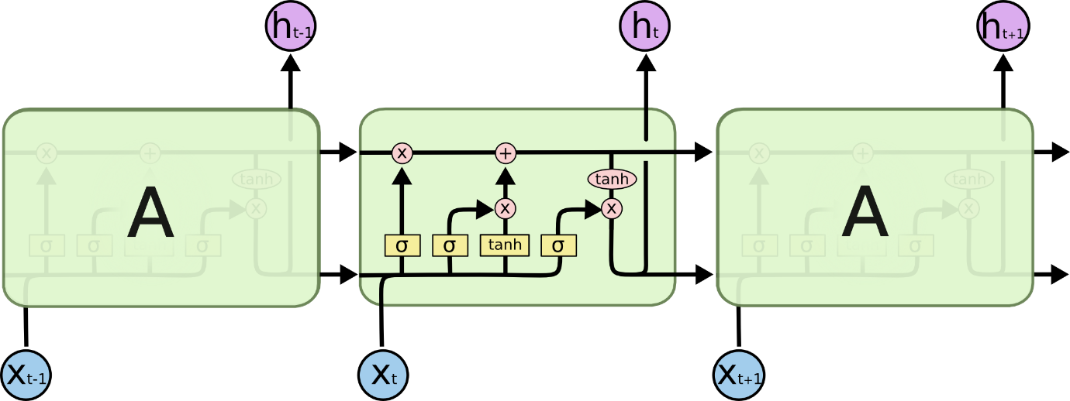

Source figure 2: <https://colah.github.io/posts/2015-08-Understanding-LSTMs/>

Mathematically, fully connected recurrent neural networks can be expressed as:

The meaning of the equation is:

New state = function with parameter c (old state, input vector at time step t).

Mathematically, LSTM-RNN can be represented in three mathematical equations:

Beginning is to decide how much past data should remember the neuron. The result is the forget gate, which decides which information to delete that is irrelevant from previous time step.

Follows by deciding how much the unit adds to the current state. The result of the equation is the input gate and it determines which information to let through based on its significance in the current time step.

Ending is to decide what part of the current cell state makes it to the output. The result is the output gate, and this allows the passed in information to impact the output in the current time step.

Both mathematical equations are from: <https://www.simplilearn.com/tutorials/deep-learning-tutorial/rnn> .

At the end, this project manages different types of files. For example, input data is in .krn format, known as humdrum [5], [6]. This type of computer files, kern, were developed by EA (Electronic Arts) Games for the NBA ’98 game [7]. EA Sports has few franchises and NBA Live is one of them, being FIFA, NFL and F1 the most popular ones. Music production has .mid format because this is the standard for professional music industry in the computerized world. MIDI files are light and hold a lot of features on the song or sound [8]. However, survey and sound analysis uses .wav files because is impossible to upload midi files to survey service provider, and wave files are perfect to understand waves and characteristics of the sound. But the size of a .wav file is approximately 100 times higher. Audacity is the technology that I will use to mix midi files output [9]. Creativity to mix music is required.

# **Design or Methodology**

The map and architecture of this project is collected on “mindmeister”. Ideas and concepts are initiated, developed, and implemented to the end. Other tools as “mural” were used to decide and choose one project, at the beginning.

Friday, 24 March 2023, last update.

This project is mainly research and investigation oriented, and it has as artefact a machine learning software that produces notes of music, plus music is analysed visually in form of spectrograms using python programming language, and visual tool to manage sound with fingers. The design of the artefact is result of the investigation. The methodology for the research is simple and consist in searching, understanding, and applying theories and ideas of other people. For example, music production, with python, whit folk mono songs, visual tool to understand images and perform specific action related to volume, analysis, and visualization of spectrograms from musical notes, comparison of different computer to perform training and other pieces of this project come from different sources, in different time, from different authors and the methodology is to select best research concepts and add to my own final year concept and artefact. Modules throw the year had huge impact in the path of this project. And class atmosphere influenced in some way this project.

There are many alternatives to the path I have taken in this project. When I started it at the end of September 2022, my modules were machine learning and data visualization. This project is about machine learning with some extra features. The classic project about image recognition or sentiment analysis and classification is too much exploited and I chose music because is different. I like to listen to good music. Thinking about future progression, I want to be a producer.

Furthermore, communication and networking are an area that I will enjoy working and sound could be a great tool for communication. Internet service providers uses light, cables, and routers today, but I believe in the power of the sound and further investigations should be done. For example, the hearing and voice ranges for different animals [10] could be a life research project for a team. A following picture clarify my idea. Sound has many features and properties, and these could be used in an interesting way.

Picture source: <https://theory.labster.com/hearing-range-dbs/>

Other routes for this project like the previous pictures are possible, but this is how it start and end and personally I think I am happy. In February 2023, research and investigation stopped to dedicate time and effort to present it. If more time used, this project could possibly have different architecture and different final artefact. Develop this artefact would be nice in a competitive and dynamic team with public resources. Five to seven people from different areas of knowledge and styles of working, each day a little bit in good academic and research conditions, would be much more productive and useful. Now, the owner of the project has a lot of knowledge, but no idea how to leverage and use it properly.

# **Implementation or Results**

* Link to the GitHub repository: [antonyitki/FYP-BSc-: Music generation with ML and DL. (github.com)](https://github.com/antonyitki/FYP-BSc-)
* Link to Colab (google GPU training model). Only ERK performed completely: <https://drive.google.com/drive/folders/1nN_g2htbrn_qTzAvx7QXGBFixXfIQ3ne?usp=sharing>

Metrics to measure the performance of the model while training are measured mathematically and collected on charts. In total there are around 15 to 18 different measures for each training model. Only training performance are measured, and not validation nor model evaluation are performed in a mathematical style. This project is supervised learning and it is a time series prediction and forecasting. There are dependence between items in a sequence and in time. The most common measures are accuracy, loss, mean absolute error (mae), mean squared error (mse), and mean absolute percentage error (mape). Metrics are mixed from regression and classification models, and therefore sometimes plots have no sense or are confusing. RNN in this project is applied to time series prediction.

MAE analysis [19]: mean absolute error is the average difference between initial values and forecast values. How far or near the predictions are from actual value. It is the inaccuracy forecast on average. Value of zero indicates that model is perfect, this is equivalent to when mae is lower, better model. Mathematically calculation follows this equation:

Where N = number of data samples

y = actual data values

Ў = predicted data value

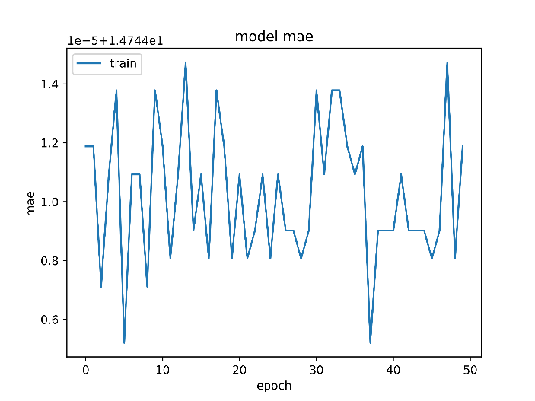

ERK, Deutsch mono folk song

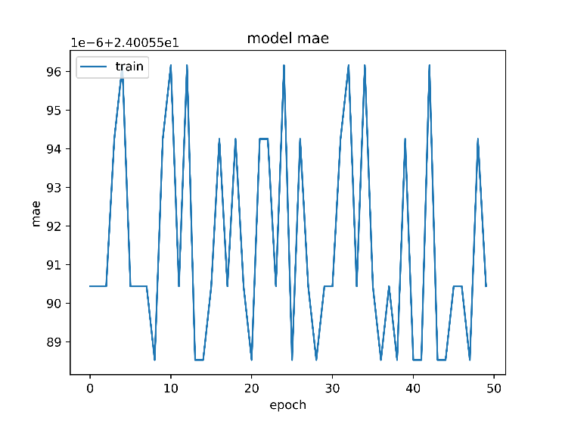

China, mix of four different styles of mono folk songs

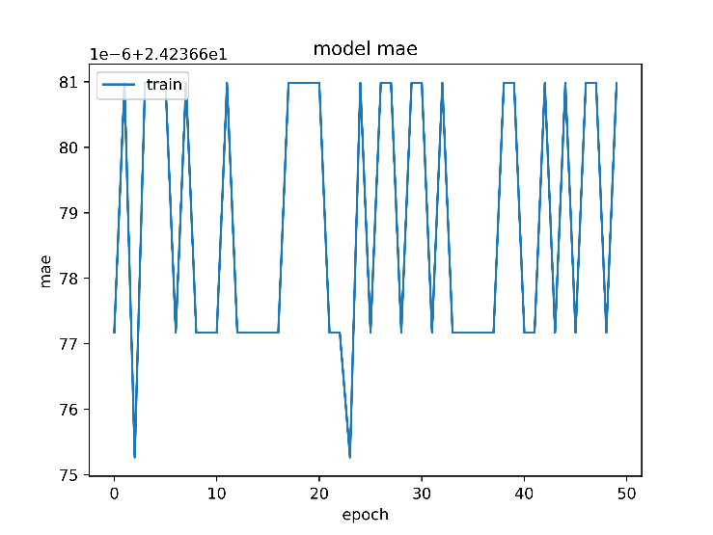

DL China, mix of four different styles of mono folk songs with addition of hidden layers in the training

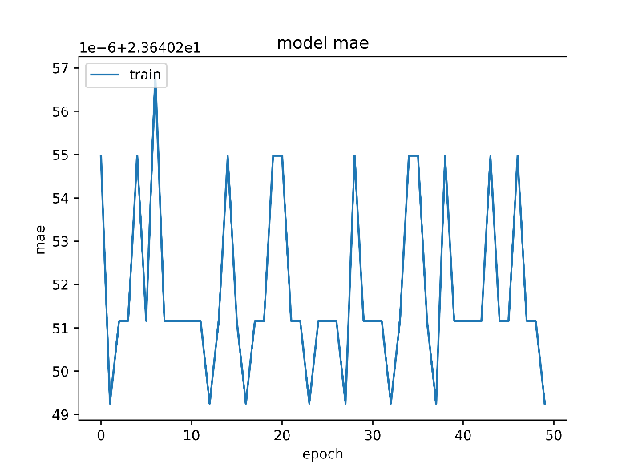

GRU China, mix of 4 styles of mono folk songs

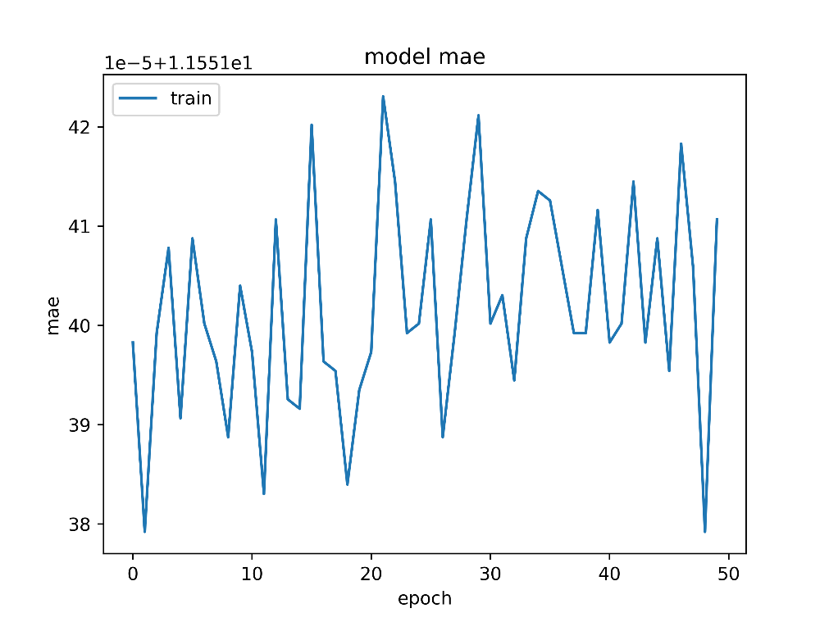

GRU ERK, pure mono songs folk from Deutschland

Another measure to analyse is accuracy. This performance metric is very popular in machine learning, and it calculates the proportion of the total number of predictions that were correct. It is used typically in classification machine learning problem, and it is used to calculate the confusion matrix because result of accuracy is the numbers of true positive, true negative, false positive and false negative values. 100 % accuracy value means that the model is perfect. Mathematically, the equation is:

A = Number of correct predictions / total number of predictions = (TP + TN) / (TP + FP + TN + FN)

Where:

TP = True positive (true prediction and true reality)

TN = True negative (false prediction and is false in reality)

FP = False positive (predicted true but is false in reality)

FN = False negative (prediction is false but reality is true)

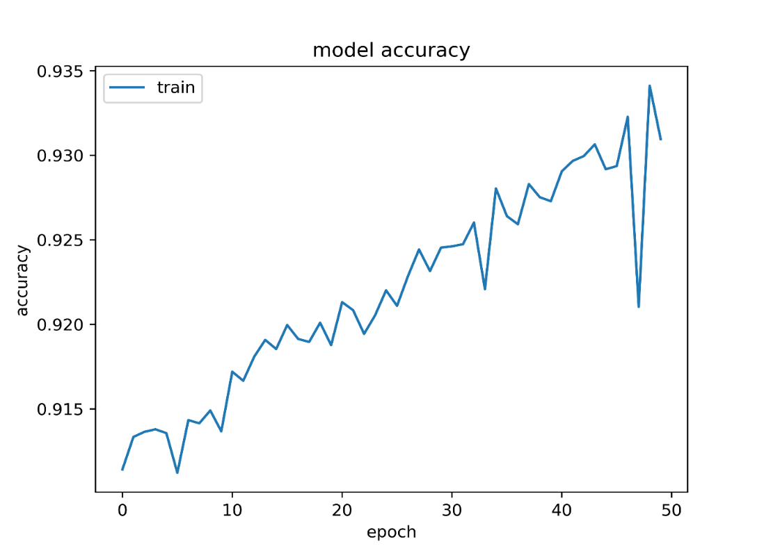

ERK, Deutsch mono folk song

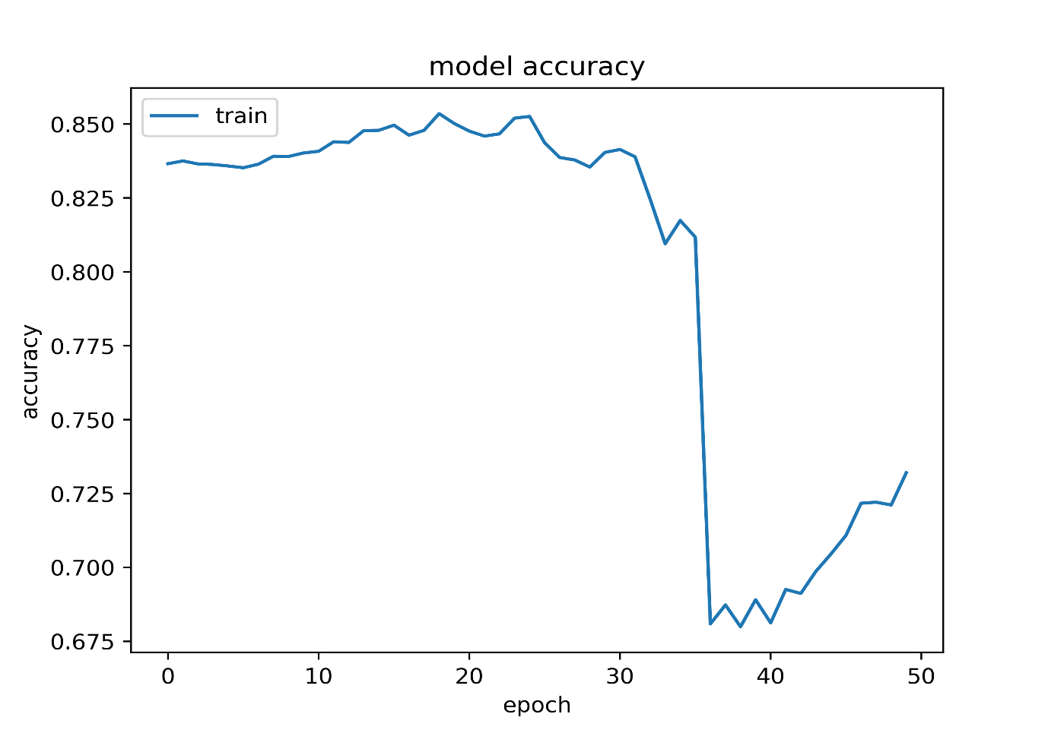

China, mix of four different styles of mono folk songs

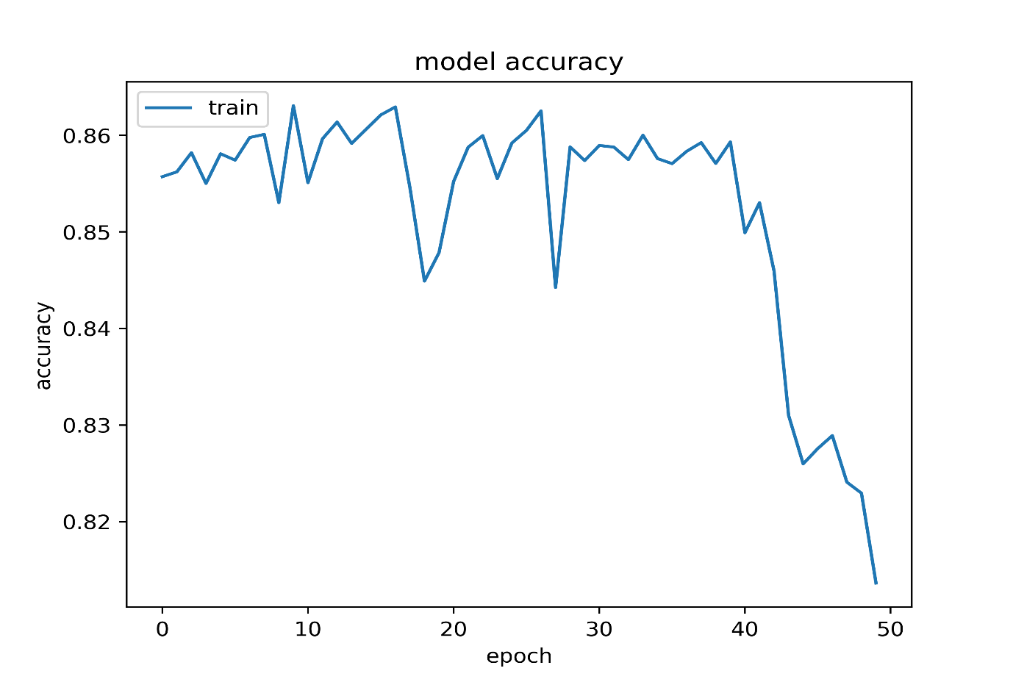

DL China, mix of four different styles of mono folk songs with addition of hidden layers in the training

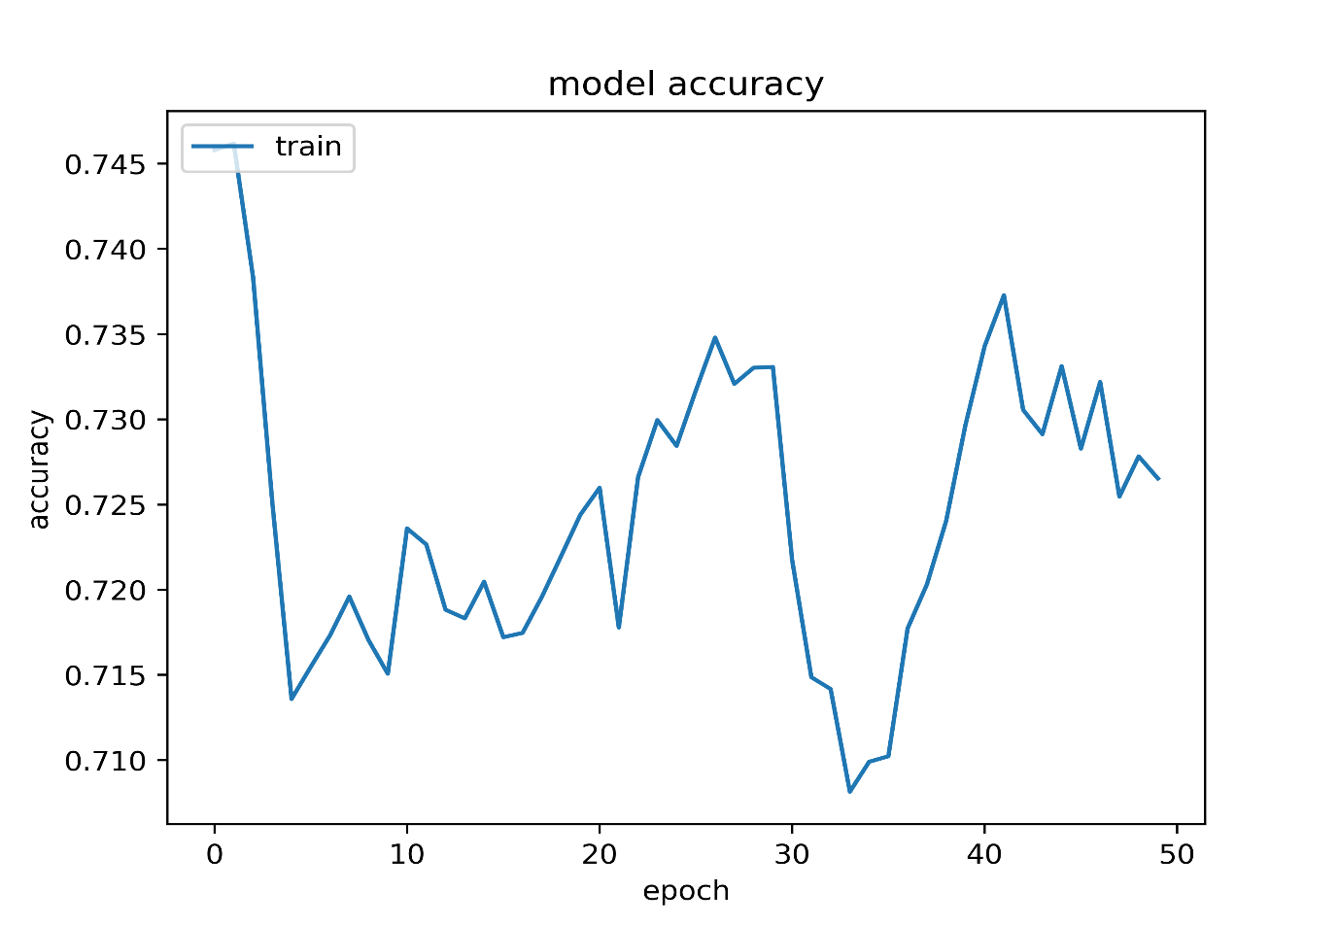

GRU China, mix of 4 styles of mono folk songs

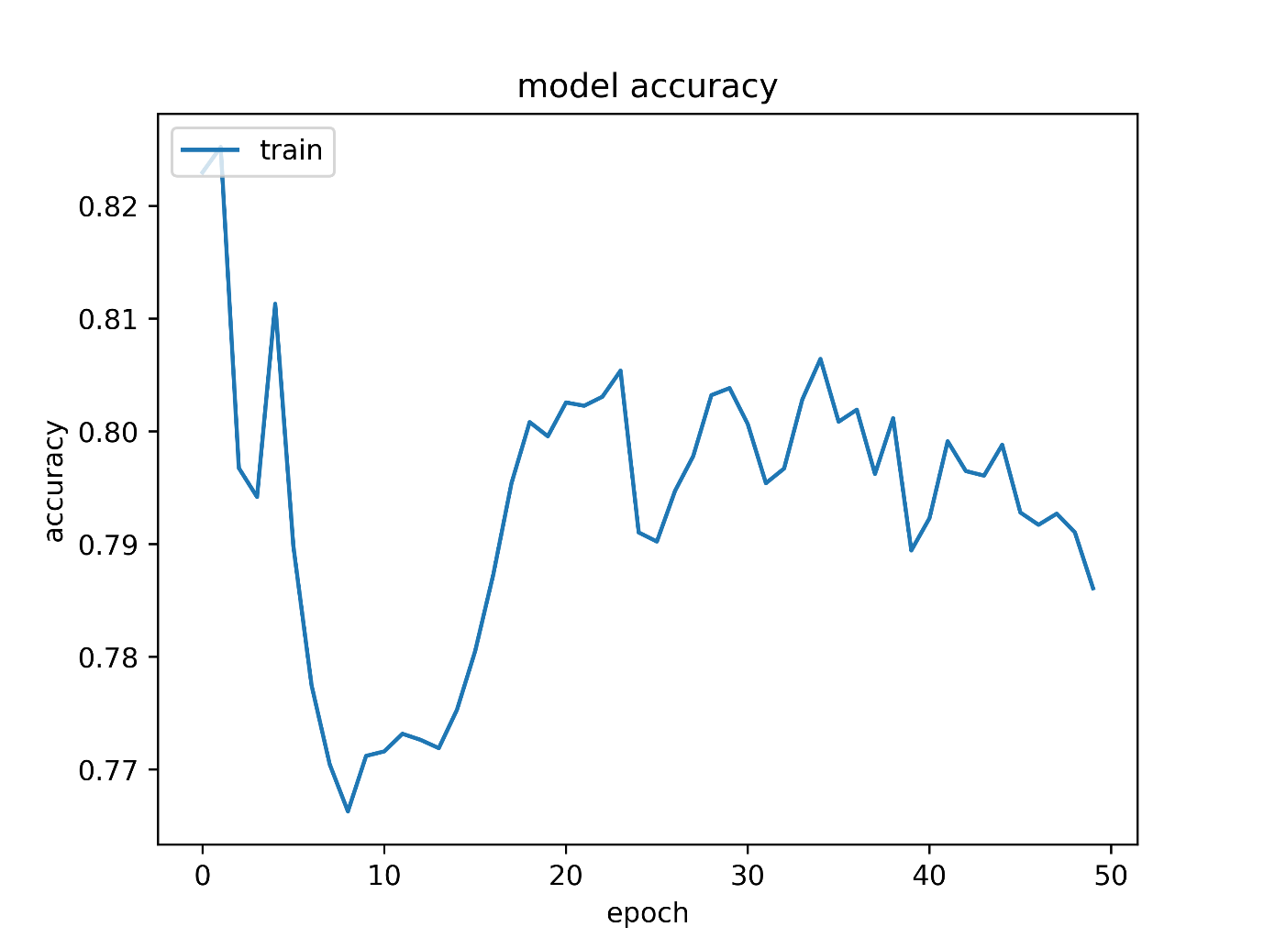

GRU ERK, pure mono songs folk from Deutschland

Analysing the pictures about accuracy, only the initial dataset performs well (ERK). The other four pictures show that model accuracy goes down and some models get it up after 35 and 8 approximately. No engineering explanation is available for this behaviour. Scientific explanation can justify this behaviour that the student laptop was used to perform other task while on training and because of the long-time taken, computer memory and resources like CPU get over working and over saturated with data and processes. Mathematically, time series prediction does not use accuracy as metric measure.

Classical survey was organised, where answers are from students, and these are analysed. Distribution was made by email. Few answers were collected and the responders like the songs.

<https://www.questionpro.com/a/TakeSurvey?tt=2joSGLiVXDr55Vk1Hl5LY7JDqCGIKL/2>

All these pictures are from a student laptop that is used during studies at Roehampton University, London (UK). And models were trained on CPU run type. Around 2 days took train the model and computer was used at minimum level during the training. Colab from Google and using GRU (Graphical processing Unit) as a runtime type was about one hour in pre-process data, train the model and plot the 15 to 17 pictures. Hardware accelerator from Colab (Google) is free of charge and can vary depending on when and where is used [20]. I believe that one of the retraining took about 20 minutes to complete. Because Google Drive service needs to be configured to access data automatically and, on the cloud, only ERK dataset was analysed until the end. Additional knowledge is necessary just to configure Google Drive with Google Colab, and cut of service could be experienced because of terms and conditions that each user signs with Google before using their services.

Use of GPU on student laptop was discarded at the beginning. Configuration needed to be done for use this feature in Keras and TensorFlow and if necessity of use CPU is needed, difficulties will arise. These are the characteristics of the student laptop used:

Processor Intel(R) Core(TM) i5-8350U CPU @ 1.70GHz 1.90 GHz

Installed RAM 16.0 GB (15.8 GB usable)

System type 64-bit operating system, x64-based processor

Finally, sound analysis is made with simple python code and music software to play, study, and learn about MIDI files was used. Audacity is free and open-source software used widely at university. MIDI files can be mixed and combined to obtain better and polyphonic music. Creativity and time are the limits to explore this great tool. Digital Signal Processing (DSP) tools and theory for networking and communication purposes is the next step in my learning and professional career. A DSP can be software installed in a computer or a physical table with computer specialized in process waves and signals. Physical tables can be of the size of a shoes box and huge enough as five student desks.

Music Score [21] [22] software was used to familiarise with musical notes and annotations. Music Score is a digital score writer software and can play the musical notes. It is a free and open-source software, written in C++ and available in all three operating systems now.

## Evaluation

This project meets 100% aims and objectives at the end. Starting from zero at the beginning, this music production project gives a lot of new knowledge to the producer, teach manage a business and project on time and okay scopes, open doors for future research and investigations and has many features like produce sound with machine learning, survey preparation distribution and evaluation, sound management with gesture recognition from camera, sound analysis with graphics using waves, familiarising with software as Muse score 3 and Audacity. Some basic music theory and notes with remembering some past music notation like musical stave, also called staff [11] [12].

The most important was to learn research style, find personal professional career and decide about future studies. Maybe musicians will use my music production to help them inspiration, originality, and creativity.

## Related Work

This project is unique in nature but is a combination of many projects found online and in the Roehampton university library. Small and medium size pieces of another project compose this project. Can be considered unique because world is old enough and no invention and creation way are huge. Now, expansion to Mars and colonization of the moon will take about 500 years to end successfully. At the same time, repetition of existing artefacts can bring new ideas, theories, and inventions. For example, penicillin was discovered in London by accident by Scottish bacteriologist [25].

This project is supportive for future discoveries and artefact creation. To be in the peak of a mountain, is necessary start from the beginning and this project is the beginning. Depending the place and the atmosphere, this project can end in a very useful and interesting artefact for the humanity.

# **Conclusion**

This music production project can be summarised as investigation-discovery oriented with no interesting new findings at present. Further studies and research is necessary and this is the plan. Study master’s in research. Furthermore, this project is helping to familiarise more with machine learning, data science and artificial intelligence. Small introduction to networking and communication knowledge was acquired and maybe the future professional path will go in this direction if decision is to challenge brain and technology.

The final tangible artefact of this project is very simple and primitive. This is a good start to build and experiment more difficult compositions. The output music can be used for inspiration to human artists, and it is possible to have a new genre of music soon. The training model was used in financial markets to predict prices of assets, but today the popular model is reinforcement learning with rewards and punishments in order. In this project same approach could be possible if survey is honestly and fast answered and integrated in the training model. The model will not produce music that stakeholders do not like and enjoy (punishment in the training process), and vice versa.

## Reflection

It is very difficult to drive lonely and with freedom a project. No idea where the end and which path to take. Just doing what comes to mind and putting as much sense as possible is difficult. Working in a team is very important for a project. Supervisor is a very important person in this type of project to have. Personally, maybe is better to find a place or business with project ideas defined and try to achieve or do better. I found not very competitive nor motivating doing this project. On the other side, more studies and time will be used and invested to finalise my project about music production and wave understanding and use for communication.

## Future Work

Experimentation, investigation, and research needed to culminate the idea of using music for communication and waves for energy utilisation. Machine learning and data is easy for me to understand and work with.

# **References and Bibliography**

References follows the IEEE standards The references are mainly for producing and supporting this report. Follows a bibliography, that I investigated and researched prior to start this project. And final Bibliography, who supports, and it is related to the project (unfinished reading). References are:

# References

|  |  |
| --- | --- |
| [1] | NASA, “What are radio waves?,” NASA, USgov, 10 August 2021. [Online]. Available: https://www.nasa.gov/directorates/heo/scan/communications/outreach/funfacts/what_are_radio_waves. [Accessed 2023 March 12]. |
| [2] | NASA, “NASA,” NASA USgov, 19 February 2019. [Online]. Available: https://www.nasa.gov/directorates/heo/scan/spectrum/overview/index.html. [Accessed 15 March 2023]. |
| [3] | V. Print, “Vistaprint,” Vistaconnect, [Online]. Available: https://www.vistaprint.co.uk/business-cards/nfc-business-cards-with-vistaconnect?PCXTVATINCLUSIVE=&utm_id=2B15323554840889544905&coupon=&partner=bing&utm_medium=cpc&utm_campaign=BING_UK_EN_Long-Tail_DSA&utm_term=vistaprint%20co&ps_vtp=415291439|1235851303. [Accessed March 2023]. |
| [4] | M. Bird, “businessinsider,” Insider, 27 Mrrch 2015. [Online]. Available: https://www.businessinsider.com/these-two-charts-show-how-the-worlds-banking-system-exploded-in-size-before-the-2008-crash-2015-3?r=US&IR=T. [Accessed 12 March 2023]. |
| [5] | V. f. Athens, “realgreekexperience,” Real Greek Experiences, 24 January 2023. [Online]. Available: https://realgreekexperiences.com/ancient-greek-philosophers. [Accessed 12 March 2023]. |
| [6] | C. S. Sapp, “Verovio Humdrum Viever,” verovio humdrum viever, 03 marz 2017. [Online]. Available: http://verovio.humdrum.org/. [Accessed 14 March 2023]. |
| [7] | b. news, “bbc news UK,” bbc, 30 May 2017. [Online]. Available: https://www.bbc.co.uk/news/world-latin-america-40090809. |
| [8] | T. i. show, “youtube,” Sound and Silence Torture - Worst Punishments in the History of Mankind, [Online]. Available: https://youtu.be/3gLB6vz24DA. |
| [9] | BBC, “BBC UK,” [Online]. Available: https://www.bbc.co.uk/news/entertainment-arts-64624525. |
| [10] | A. Devices, “A Beginner's Guide to Digital Signal Processing (DSP),” Ahead of what's possible, [Online]. Available: https://www.analog.com/en/design-center/landing-pages/001/beginners-guide-to-dsp.html. |
| [11] | Devialet, “Phantom speakers (most expensive speaker model),” Devialet, [Online]. Available: https://www.devialet.com/en-gb/phantom-speaker/. |
| [12] | RSU, “Growhampton,” [Online]. Available: https://www.roehamptonstudent.com/growhampton/. |
| [13] | “Humdrum toolkit,” [Online]. Available: https://www.humdrum.org/index.html. |
| [14] | P. s. Mozart, “Vevorio Humdrum Viever,” Vevorio Humdrum Viever, [Online]. Available: http://verovio.humdrum.org/?file=mozart/sonatas/sonata05-1.krn. |
| [15] | J. Geater, “Solvusoft,” Silver Microsoft Partner, 26 November 2018. [Online]. Available: https://www.solvusoft.com/en/file-extensions/file-extension-krn/. [Accessed March 2023]. |
| [16] | M. Association, “midi.org,” [Online]. Available: https://www.midi.org/specifications. |
| [17] | Audacity, “Audacity software,” [Online]. Available: https://www.audacityteam.org/download/windows/. |
| [18] | L. theory, “Theory labster,” labster, [Online]. Available: https://theory.labster.com/hearing-range-dbs/. [Accessed March 2023]. |
| [19] | V. Lendave, “aim,” Analytics India Magazine, 01 November 2021. [Online]. Available: https://analyticsindiamag.com/a-guide-to-different-evaluation-metrics-for-time-series-forecasting-models/. [Accessed 19 Marz 2023]. |
| [20] | G. Colaboratory, “Google,” Google, [Online]. Available: https://research.google.com/colaboratory/faq.html#gpu-availability. [Accessed 19 Marz 2023]. |
| [21] | [Online]. Available: https://musescore.org/en. |
| [22] | [Online]. Available: https://musescore.org/en/3.0. |
| [23] | D. Farrant, “Hello music theory,” 25 June 2022. [Online]. Available: https://hellomusictheory.com/learn/the-stave/. [Accessed 01 March 2023]. |
| [24] | Britanica, “Britannica,” Britannica encyclopedia, [Online]. Available: https://www.britannica.com/art/staff. |
| [25] | A. Augustyn., “brittanica.com,” brittanica enciclopedia, [Online]. Available: https://www.britannica.com/science/penicillin. [Accessed 22 Marz 2023]. |

Bibliography that inspired the beginning of the project and give me more suggestions on developing and ending it. Sources are ordered chronologically, starting on top at the beginning and at the bottom more recent information to end the project and think about future expansion of the project or work. These are videos, websites, and some academic articles:

* <https://magenta.tensorflow.org/>
* [Generate music with an RNN  |  TensorFlow Core](https://www.tensorflow.org/tutorials/audio/music_generation#:~:text=Generate%20music%20with%20an%20RNN%201%20Setup%20This,train%20the%20model%20...%208%20Generate%20notes%20)
* [https://cs229.stanford.edu/proj2018/report/18.pdf](https://eur02.safelinks.protection.outlook.com/?url=https%3A%2F%2Fcs229.stanford.edu%2Fproj2018%2Freport%2F18.pdf&data=05%7C01%7Cramonola%40roehampton.ac.uk%7C2340b99281c343979e5c08daac614b72%7C5fe650635c3747fbb4cce42659e607ed%7C0%7C0%7C638011831112540390%7CUnknown%7CTWFpbGZsb3d8eyJWIjoiMC4wLjAwMDAiLCJQIjoiV2luMzIiLCJBTiI6Ik1haWwiLCJXVCI6Mn0%3D%7C3000%7C%7C%7C&sdata=zCkZiNyg22uliE2gaR8W%2FbAZ091bhOxTse5NEe5BWoc%3D&reserved=0)
* <https://www.youtube.com/playlist?list=PL-wATfeyAMNr0KMutwtbeDCmpwvtul-Xz>
* [45871.pdf (googleusercontent.com)](https://static.googleusercontent.com/media/research.google.com/en/pubs/archive/45871.pdf)
* [IJISRT22MAY250_(1).pdf](https://ijisrt.com/assets/upload/files/IJISRT22MAY250_(1).pdf)
* [Music Generation for Novices Using Recurrent Neural Network (RNN) | IEEE Conference Publication | IEEE Xplore](https://ieeexplore.ieee.org/document/9633906)
* [(PDF) Music transcription modelling and composition using deep learning (researchgate.net)](https://www.researchgate.net/publication/301818301_Music_transcription_modelling_and_composition_using_deep_learning)
* <https://emerj.com/ai-sector-overviews/musical-artificial-intelligence-6-applications-of-ai-for-audio/>
* <https://youtube.com/playlist?list=PL-wATfeyAMNqIee7cH3q1bh4QJFAaeNv0>
* <https://youtube.com/playlist?list=PLMoSUbG1Q_r-7xWY3Oh2yOFp3EoxNOphH>
* <https://youtu.be/eCvz-kB4yko>
* <https://youtu.be/DY82Goknf0s>
* <https://youtu.be/Oa_d-zaUti8>
* <https://youtu.be/uk96O7N1Yo0>

|  |  |  |  |  |  |  |  |  |  |  |
| --- | --- | --- | --- | --- | --- | --- | --- | --- | --- | --- |
| |  |  |  |  |  |  |  | | --- | --- | --- | --- | --- | --- | --- | | |  |  |  |  | | --- | --- | --- | --- | | |  | | --- | | **A Hands-On Guide to Automatic Music Generation using RNN** | | |  | | --- | |  | | | | [A Hands-On Guide to Automatic Music Generation using RNN](https://analyticsindiamag.com/a-hands-on-guide-to-automatic-music-generation-using-rnn/) | | [A picture containing text, stage, swimming  Description automatically generated](https://analyticsindiamag.com/a-hands-on-guide-to-automatic-music-generation-using-rnn/) | | |  | | --- | | [analyticsindiamag.com](https://analyticsindiamag.com/a-hands-on-guide-to-automatic-music-generation-using-rnn/) | |  | |

|  |  |  |  |  |  |  |  |  |
| --- | --- | --- | --- | --- | --- | --- | --- | --- |
| |  |  |  |  |  |  | | --- | --- | --- | --- | --- | --- | | |  |  |  |  | | --- | --- | --- | --- | | |  | | --- | | **https://towardsdatascience.com/how-to-generate-music-using-a-lstm-neural-network-in-keras-687868** | | |  | | --- | | <https://towardsdatascience.com/how-to-generate-music-using-a-lstm-neural-network-in-keras-68786834d4c5#:~:text=Music21%20is%20a%20Python%20toolkit%20used%20for%20computer-aided,to%20acquire%20the%20musical%20notation%20of%20MIDI%20files.> | | | |  | | | |  | | --- | |  | | |

|  |  |  |  |  |  |  |  |
| --- | --- | --- | --- | --- | --- | --- | --- |
| |  |  |  |  |  |  | | --- | --- | --- | --- | --- | --- | | |  |  |  |  | | --- | --- | --- | --- | | |  | | --- | | **https://blog.eduonix.com/artificial-intelligence/impact-ai-music-pre-processing-using-python/** | | |  | | --- | | <https://blog.eduonix.com/artificial-intelligence/impact-ai-music-pre-processing-using-python/> | | | |  | | |  | |

|  |  |  |  |  |  |  |  |
| --- | --- | --- | --- | --- | --- | --- | --- |
| |  |  |  |  |  |  | | --- | --- | --- | --- | --- | --- | | |  |  |  |  | | --- | --- | --- | --- | | |  | | --- | | **https://python-course.eu/applications-python/musical-scores-with-python.php** | | |  | | --- | | <https://python-course.eu/applications-python/musical-scores-with-python.php> | | | |  | | |  | |

|  |  |  |  |  |  |  |  |  |  |  |
| --- | --- | --- | --- | --- | --- | --- | --- | --- | --- | --- |
| |  |  |  |  |  |  |  | | --- | --- | --- | --- | --- | --- | --- | | |  |  |  |  | | --- | --- | --- | --- | | |  | | --- | | **Music Generation | Chan`s Jupyter** | | |  | | --- | | [Music Generation | Chan`s Jupyter](https://goodboychan.github.io/python/tensorflow/mit/2021/02/14/music-generation.html) | | | |  | | [Music Generation | Chan`s Jupyter](https://goodboychan.github.io/python/tensorflow/mit/2021/02/14/music-generation.html) | | |  | | --- | | [github.io](https://goodboychan.github.io/python/tensorflow/mit/2021/02/14/music-generation.html) | |  | |

|  |  |  |  |  |  |  |  |  |
| --- | --- | --- | --- | --- | --- | --- | --- | --- |
| |  |  |  |  |  |  | | --- | --- | --- | --- | --- | --- | | |  |  |  |  | | --- | --- | --- | --- | | |  | | --- | | **Generate Audio with Python - Zach Denton** | | |  | | --- | | [Generate Audio with Python - Zach Denton](https://zach.se/generate-audio-with-python/) | | | |  | | | |  | | --- | | [zach.se](https://zach.se/generate-audio-with-python/) | | |

|  |  |  |  |  |  |  |  |  |  |  |
| --- | --- | --- | --- | --- | --- | --- | --- | --- | --- | --- |
| |  |  |  |  |  |  |  | | --- | --- | --- | --- | --- | --- | --- | | |  |  |  |  | | --- | --- | --- | --- | | |  | | --- | | **Generate Music Using TensorFlow and Python | Rubik's Code** | | |  | | --- | | [Generate Music Using TensorFlow and Python | Rubik's Code](https://rubikscode.net/2018/11/12/generate-music-using-tensorflow-and-python/) | | | |  | | [Diagram, icon  Description automatically generated](https://rubikscode.net/2018/11/12/generate-music-using-tensorflow-and-python/) | | |  | | --- | | [rubikscode.net](https://rubikscode.net/2018/11/12/generate-music-using-tensorflow-and-python/) | |  | |

|  |  |  |  |  |  |  |  |  |  |  |
| --- | --- | --- | --- | --- | --- | --- | --- | --- | --- | --- |
| |  |  |  |  |  |  |  | | --- | --- | --- | --- | --- | --- | --- | | |  |  |  |  | | --- | --- | --- | --- | | |  | | --- | | **The Top 20 Python Deep Learning Tensorflow Music Open Source Projects** | | |  | | --- | | [The Top 20 Python Deep Learning Tensorflow Music Open Source Projects](https://awesomeopensource.com/projects/deep-learning/music/python/tensorflow) | | | |  | | [Graphical user interface, text, application, email  Description automatically generated](https://awesomeopensource.com/projects/deep-learning/music/python/tensorflow) | | |  | | --- | | [awesomeopensource.com](https://awesomeopensource.com/projects/deep-learning/music/python/tensorflow) | |  | |

|  |  |  |  |  |  |  |  |  |  |  |
| --- | --- | --- | --- | --- | --- | --- | --- | --- | --- | --- |
| |  |  |  |  |  |  |  | | --- | --- | --- | --- | --- | --- | --- | | |  |  |  |  | | --- | --- | --- | --- | | |  | | --- | | **abc:standard:v2.1 [abc wiki]** | | |  | | --- | | [abc:standard:v2.1 [abc wiki]](http://abcnotation.com/wiki/abc:standard:v2.1) | | | |  | | [Graphical user interface, application, email  Description automatically generated](http://abcnotation.com/wiki/abc:standard:v2.1) | | |  | | --- | | [abcnotation.com](http://abcnotation.com/wiki/abc:standard:v2.1) | |  | |

|  |  |  |  |  |  |  |  |  |  |  |
| --- | --- | --- | --- | --- | --- | --- | --- | --- | --- | --- |
| |  |  |  |  |  |  |  | | --- | --- | --- | --- | --- | --- | --- | | |  |  |  |  | | --- | --- | --- | --- | | |  | | --- | | **AIVA - The AI composing emotional soundtrack music** | | |  | | --- | | [AIVA - The AI composing emotional soundtrack music](https://aiva.ai/) | | | |  | | [A screenshot of a computer screen  Description automatically generated with medium confidence](https://aiva.ai/) | | |  | | --- | | [aiva.ai](https://aiva.ai/) | |  | |

|  |  |  |  |  |  |  |  |  |  |  |
| --- | --- | --- | --- | --- | --- | --- | --- | --- | --- | --- |
| |  |  |  |  |  |  |  | | --- | --- | --- | --- | --- | --- | --- | | |  |  |  |  | | --- | --- | --- | --- | | |  | | --- | | **MuseNet** | | |  | | --- | | [MuseNet](https://openai.com/blog/musenet/) | | | |  | | [Background pattern  Description automatically generated](https://openai.com/blog/musenet/) | | |  | | --- | | [openai.com](https://openai.com/blog/musenet/) | |  | |

|  |  |  |  |  |  |  |  |  |  |  |
| --- | --- | --- | --- | --- | --- | --- | --- | --- | --- | --- |
| |  |  |  |  |  |  |  | | --- | --- | --- | --- | --- | --- | --- | | |  |  |  |  | | --- | --- | --- | --- | | |  | | --- | | **Long short-term memory (LSTM) with Python – Data Science, Machine Learning, Deep Learning** | | |  | | --- | | [Long short-term memory (LSTM) with Python – Data Science, Machine Learning, Deep Learning](https://www.alpha-quantum.com/blog/long-short-term-memory-lstm-with-python/long-short-term-memory-lstm-with-python/) | | | |  | | [Graphical user interface, text, application  Description automatically generated](https://www.alpha-quantum.com/blog/long-short-term-memory-lstm-with-python/long-short-term-memory-lstm-with-python/) | | |  | | --- | | [alpha-quantum.com](https://www.alpha-quantum.com/blog/long-short-term-memory-lstm-with-python/long-short-term-memory-lstm-with-python/) | |  | |

Bibliography reading academic paper and academic conferences before starting to implement this project follows. These are technical academic paper produced by professionals. 5 papers are by my own research finding and 2 are findings and recommendation from my supervisor (Dr Li):

* A Comprehensive Survey on Deep Music Generation: Multi-level Representations, Algorithms, Evaluations, and Future Directions; SHULEI JI, JING LUO, and XINYU YANG, School of Computer Science and Technology, Xi’an Jiaotong University, China (96 sheets, recommendation from my supervisor Dr Li).
* Music Generation Using Deep Learning; Vaishali Ingale Army Institute of Technology [vingale@aitpune.edu.in](mailto:vingale@aitpune.edu.in) Anush Mohan Army Institute of Technology [anushmohan_17380@aitpune.edu.in](mailto:anushmohan_17380@aitpune.edu.in) Divit Adlakha Army Institute of Technology [divitadlakha_17493@aitpune.edu.in](mailto:divitadlakha_17493@aitpune.edu.in) Krishna Kumar Army Institute of Technology [krishnakumar_17564@aitpune.edu.in](mailto:krishnakumar_17564@aitpune.edu.in) Mohit Gupta Army Institute of Technology [mohitgupta_17429@aitpune.edu.in](mailto:mohitgupta_17429@aitpune.edu.in) (5 sheets, recommendation from my supervisor Dr Li).
* Project milestone: Generating music with Machine Learning; David Kang Stanford dwkang Jung Youn Kim Stanford jyk423 Simen Ringdahl Stanford ringdahl (6 sheets, own research).
* Generating Music by Fine-Tuning Recurrent Neural Networks with Reinforcement Learning; Natasha Jaques12, Shixiang Gu13, Richard E. Turner3 , Douglas Eck1 1Google Brain, USA 2Massachusetts Institute of Technology, USA 3University of Cambridge, UK [jaquesn@mit.edu](mailto:jaquesn@mit.edu), [sg717@cam.ac.com](mailto:sg717@cam.ac.com), [ret26@cam.ac.uk](mailto:ret26@cam.ac.uk), [deck@google.com](mailto:deck@google.com) (11 sheets, own research).
* Volume Control using Gestures; Martendra Pratap Singh, Arzoo Poswal, Eshu Yadav (4 sheets, own research).
* Music Generation for Novices Using Recurrent Neural Network (RNN); Sahreen Sajad, S Dharshika and Merin Meleet Department of ISE, R.V. College of Engineering, Karnataka-India, (6 sheets, own research).
* Music transcription modelling and composition using deep learning; Bob L. Sturm 1 , Jo˜ao Felipe Santos 2 , Oded Ben-Tal 3 and Iryna Korshunova 4 ? 1 Centre for Digital Music, Queen Mary University of London 2 INRS-EMT, Montreal Canada 3 Music Department, Kingston University, UK 4 ELIS, Ghent University, Belgium (17 sheets, own research).

Finally, more bibliography unfinished reading, but it is relevant and is possible to use for future investigation or production of this project:

* Third International Conference on Computing and Network Communications (CoCoNet’19) An Improved RNN-LSTM based Novel Approach for Sheet Music Generation; Mohit Duaa , Rohit Yadavb , Divya Mamgaic , Sonali Brodiyad a,b,c,dDepartment of Computer Engineering, National Institute of Technology, Kurukshetra 136119, India
* A Dataset and Taxonomy for Urban Sound Research; Justin Salamon1,2, Christopher Jacoby1 , Juan Pablo Bello1 1Music and Audio Research Laboratory, New York University 2Center for Urban Science and Progress, New York University {justin.salamon, cbj238, [jpbello}@nyu.edu](mailto:jpbello%7d@nyu.edu)
* THE PERLHUMDRUM AND PERLLILYPOND TOOLKITS FOR SYMBOLIC MUSIC INFORMATION RETRIEVAL; Ian Knopke Goldsmiths Digital Studios [ian.knopke@gmail.com](mailto:ian.knopke@gmail.com)
* A Review of the Humdrum Toolkit: UNIX Tools for Musical Research, Created by David Huron; Jonathan Wild
* Empirical Evaluation of Gated Recurrent Neural Networks on Sequence Modeling; Junyoung Chung Caglar Gulcehre KyungHyun Cho Universite de Montr ´ eal ´ Yoshua Bengio Universite de Montr ´ eal ´ CIFAR Senior Fellow
* ONLINE DATABASE OF SCORES IN THE HUMDRUM FILE FORMAT; Craig Stuart Sapp Center for Computer Assisted Research in the Humanities Stanford University Centre for the History and Analysis of Recorded Music Royal Holloway, University of London [craig@ccrma.stanford.edu](mailto:craig@ccrma.stanford.edu)
* Humdrum: Files and Procedures (see picture)

# **Appendices**